Artist News.
Well what an amazing time.
People and Places at the Art Gallery of Ballarat Backspace Gallery was a fabulous event for Alan and myself.
Portraits heading of to their new homes.
At the completion of the exhibition feeling as if I had made a sand Mandela as the portraits were taken of the wall. Realizing I shall never see this installation together again.
Commissions have arisen out of these works. So the oil sketches continue.
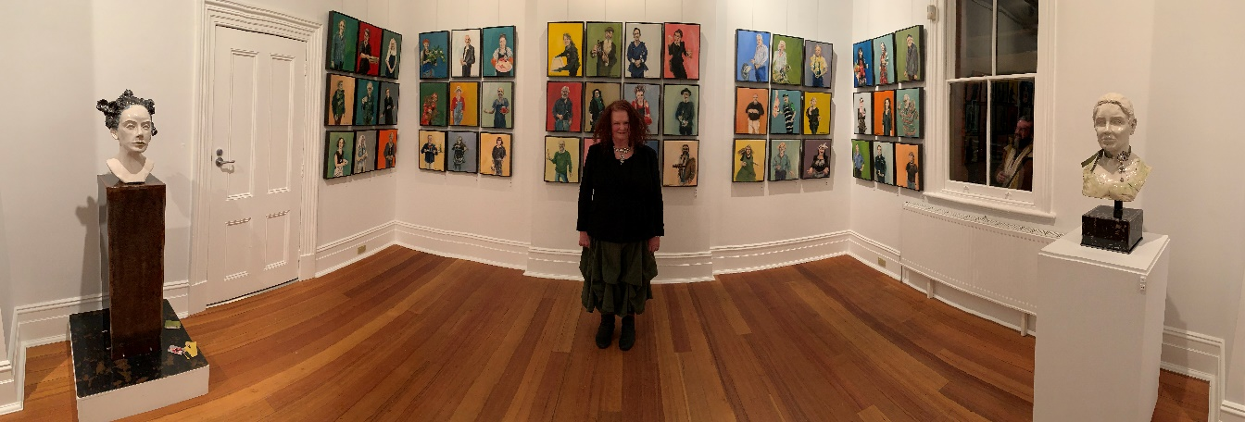

I have an exhibition called SHADES at the Convent Gallery Daylesford.
This has given me an opportunity to exhibit Drawings and Sculptures.
I am delighted with the beautiful airy Gallery space that gives my work a sense of, as a friend said Elegance.
My wonderful Web designer has been at doing her magic on my WWW. alisonparkinson.com
Shades is visible on line, especially on a PC
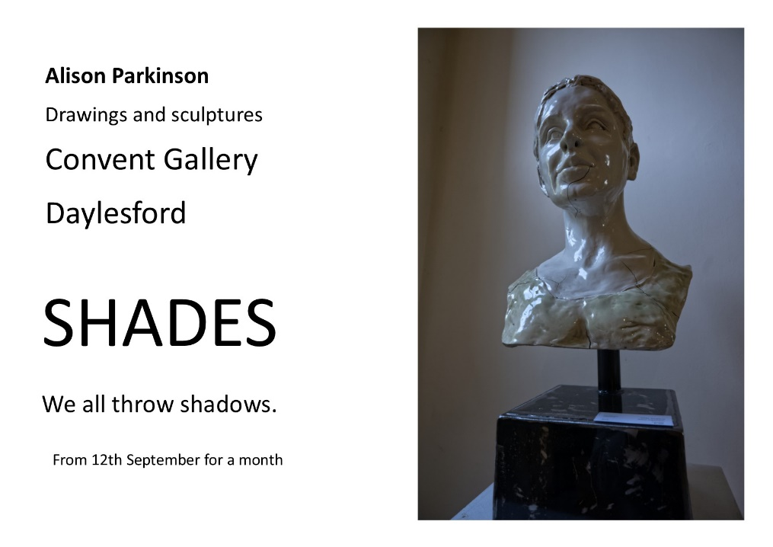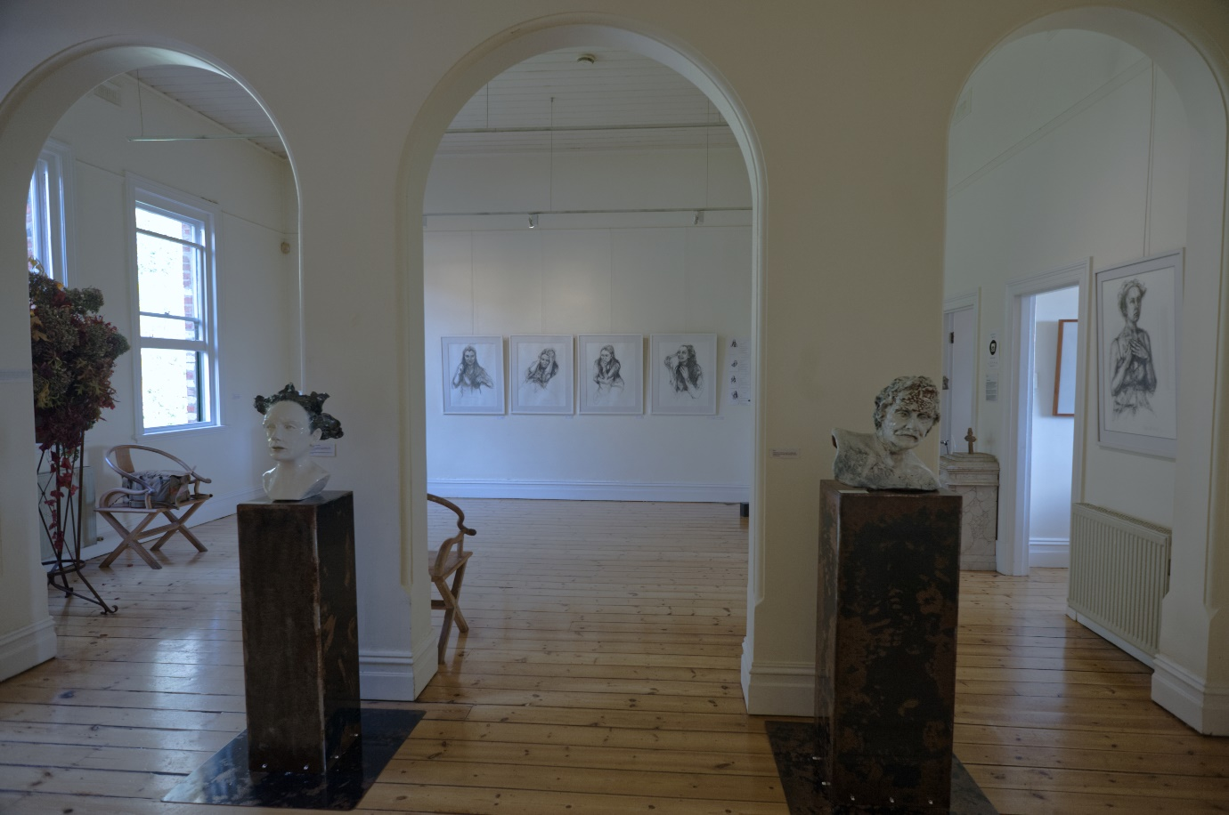

Repertior Gallery and my Studio are now open on Saturdays 12pm – 4pm.
3149 Midland Highway Mount Prospect
Opportunity to talk art, look at what I am up to or perhaps talk about a commission for portrait or jewellery.
Warm Wishes to you all,
Alison

